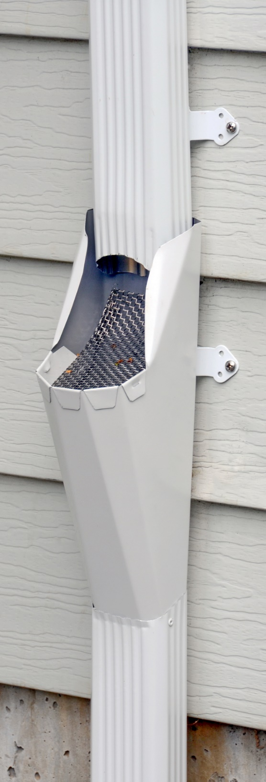
Leaf-Catcher DIY
Installation Instruction
(updated 7/13)

http://dmr-gutters.com
Part List:
1 copper or painted aluminum LC (Leaf-Catcher) w/6X6 stainless steel screen in it, 3 Pipe Cleats, 22 rivets, 6 to 18 SS (stainless steel) screws. #3 Philips tip.

Tool List:
Sturdy ladder, hammer, cat’s paw, cordless impact driver, a vertically calibrated level, 1/4” hex socket, #2 & #3 Phillips tip, 1/8” drill bit, hand riveter, tin snips, 5 blade crimper, hacksaw, circular saw, or chop saw.

Note: an impact driver works on screws a lot better than a drill/driver. Especially these stainless steel screws. If you don’t have an impact driver yet this is a great time to invest in one. I prefer the LXDT01 Makita 18V.

1. DSP Removal:
It is too difficult and dangerous to try and cut out a section of DSP (downspout pipes) for the LC while still mounted on the siding, so remove your old DSP from the house with a hammer and cat’s paw tool if they are attached with nails. Some DSP are attached with straps that have a fastener hidden behind the DSP. If so there should be a small zip screw in front or on the sides of the DSP. Remove it with a 1/4 hex socket to loosen the strap, which should dislocate the DSP. If you are going to re-use your old DSP parts then you will need to carefully remove them w/o denting or scratching them up. That’s why I also provide an extra set of 2 Pipe Cleats, rivets, and stainless steel screws for remounting the whole DSP in the same manner as the LC.

2. Storm-Drain Pipe Preparation:
This is a good time to check the underground SDP (storm-drain pipe) for blockage. It may be clogged with years of decomposed debris and roof sand. Use a garden hose to check to see if it is flowing properly. It should be able to take the full stream of water for 5 to 10 minutes w/o backing up and overflowing. If it is clogged you may be able to clear it with a small fire-hose type nozzle on the end of your hose to blast it free. A small shutoff valve just before the nozzle also helps. Work the end of the hose down into that SDP with the water running to blast through and free up any blockage as far as you can manage. If that does not take care of it within a half hour of working on each SDP that’s clogged you may need to call in a Rooter company to clear out the blockages. They are usually successful in clearing out those obstructions. They should have high pressured water and a motorized snake tool that can even grind up roots that may have somehow grown inside your SDP. If needed they can run a small camera down the pipe to see what is going on and look for fractures. This way they can see if the pipe is broken or dislocated underground.

If your SDP extend up more than a foot above the ground, you should cut it down a bit for appearance sake. If they are less than 6” from the ground they are too low and should be extend up. A low SDP can allow for rocks and other debris to fall into them and get plug up.

3. Setting the Height of the Leaf-Catcher:
Some think of these strainers as unsightly and want these mounted down as low as possible, but I’ve found this to be a problem. Besides being hard to reach they will be forgotten and not get cleaned out often enough; being out of sight. You could think of these as a deluxe feature with bragging rights. I recommend this strainer section of the LC should be set a yard (3’) above the ground surface where the Homeowner would likely be standing when they clean out this LC basket. Sometimes the best placement is up by a second story deck, so carefully explore all the options before deciding where to mount the LC. The DSP section to go under the LC should be cut to have the top edge be 26” above the standing surface minus the height of the SDP it will be going into, but then add another 1.5” for the DSP to fit down inside the SDP.

4. Cutting the Bottom Section of Downspout Pipe:
Measure and mark the length of DSP to be cut for use below the LC. Aluminum and copper downspouts can easily be cut with a regular wood cutting carbide tooth saw blade, but do not use an electric saw on steel DSP or you will destroy the blade and risk danger. You can check this with a magnet. Only steel will attract a magnet. Try to keep in mind what part of your saw could scratch up the paint on the DSP or dent it while cutting. Applying some duct tape on the saw plate can help to solve this issue. Cut the desired length from your DSP at a 22.5 degree angling down in the front with the front of the pipe lower than the back. You can just square cut it and use tin snips to trim the top edge of that DSP section at an angle along the sides (as in the photo above). Trim it about ¾” lower in the front, to give the Leaf-catcher a better secure fit in the DSP. Test fit them together before riveting them checking for alignment.

5. Attaching the Leaf-Catcher to the DSP:
Fit the LC into the lower DSP section making sure the back of the LC is in alignment with that DSP. Drill 1/8” holes on each side near the front through the top of the DSP in through the LC. After drilling the first hole set the rivet in the hole to hold that alignment for you while drilling the other hole. Without this it is very likely to shift on you. Then two more rivets go in backside, again checking to see the backside is straight. Then use the rivet hand tool to pop them together. The pop rivet tool is to grip the shaft of the rivet sticking out pulling the larger head into the barrel of the rivet making it swell on the other end from the washer side locking the 2 pieces of metal together.

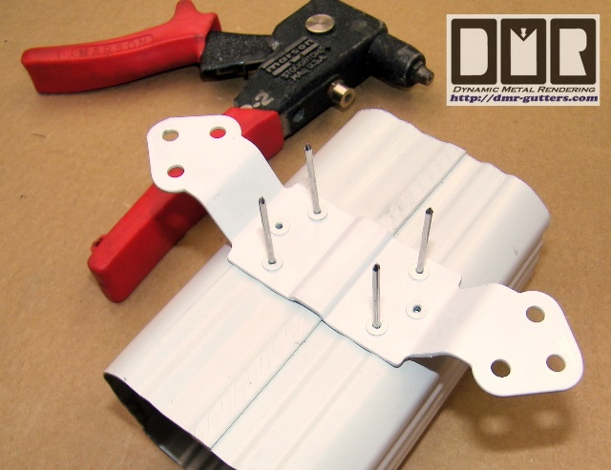
6. Pipe Cleat Attachments:
If the Pipe Cleat bracket is not already attached to the LC then you’ll need to rivet it on using all 6 rivet holes. Set the pipe cleat just behind the strainer screen, but you should test fit it on your wall to make sure the pipe cleat will be in the best possible position to the siding layers, or the mortar joints between the bricks. Never screw them into the brick. You are now ready to install the LC on the wall with the provided SS screws in the outer holes of pipe cleat using the #3 Phillips tip. For copper DSP I recommend using screws in all 3 holes on each side to deter thieves. You should use a vertically calibrated level to make sure it is mounted straight vertically, since eye-balling it alone can deceive. Set the level on the DSP below the LC, because the LC housing is tapered and would give you a false reading. If attaching this to a 4X4 post or corner trim boards you will see the Pipe Cleats are too wide. They can be bent back across the 2 inner holes to form a side mount into the 4X4 beam.

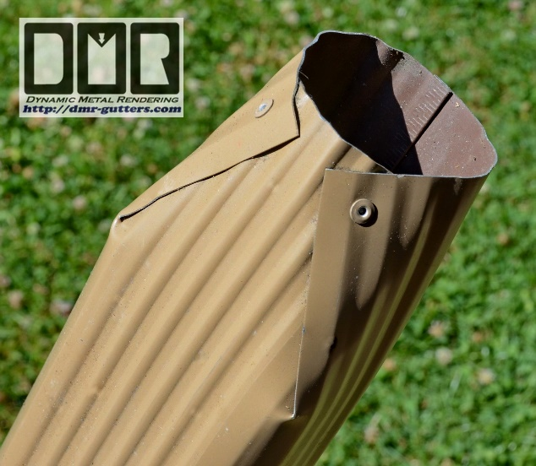
7. Fitting DSP into SDP:
It’s best to have a Straight Connector on top of your 3” ABS pipe for 2X3 DSP to fit into. If not the bottom of your DSP would need to be funneled down a little, so it can extend 1” to 1.5” down into your 3” pipe. Cut 2 slits 3” up from the bottom in the back corners of the DSP to fit with a SDP which is set a little outside of the wall, or cut just the front corners for a SDP very close to the siding or under it a little. Then overlap those tabs to make it funnel. Make sure to leave at least a 2” wide hole in the bottom of this DSP. You should pull the other side out with your thumb while pushing in with your knuckle down a couple inches from the end to help round out this bottom hole. Rivet those over-lapping tabs together, so they do not close up even more when pushing it down snugly into your SDP. Check for vertical angle and run the screws in.

8. The Upper Downspout Pipe Section:
With the elbows in place hold up the remaining DSP on the wall beside the LC to mark the cutoff point below. Make sure to have your upper DSP long enough to protrude 1.5” to 2” down into the top edge of the LC. Cut the DSP off at the marked spot. You should also cut a small arch in the front bottom edge of the DSP. Then crimp in the bottom edge of the DSP to help funnel the rain water into the screen of the LC, so the rain water doesn’t splatter out the opening as much. Attach the elbows to the top of the DSP with a rivet on each side of each connection. Install the 2 extra Pipe Cleats on the backside of that vertical DSP after determining the best placement with regards to your siding, so they look evenly spaced. Mount 1 up high about 6” down from elbow, and the lower Pipe Cleat 6” or so up from the bottom. Make sure to position this upper DSP 1.5” to 2” down inside the LC unit. Then screw it on the house siding with the provided SS screws. If you have vinyl siding you may need longer screws to reach the wood behind. That’s all it should need. Each DSP re-mastering should only take you an hour to do.

9. Maintenance:
The LC should be checked for debris buildup at least 4 times a year to clear them out. I could make these with removable baskets for easier dumping, but they would wind up getting damaged or lost with regular use, so that is not practical. The screen is angled to allow excess debris to be forced out if left unchecked. The outer rim of the basket helps to keep the rain water inside the LC, and should not be altered. I had made removable covers for the open screen area to make it look cleaner and eliminate any splattering outside the housing, but that proved to be more problematic than helpful; out-of-sight also means out-of-mind. The upper DSP will become impacted with debris before the problem was discovered.

If you have questions or problem w/installation contact: David Rich, cell # (503) 351-7082
(as it would be a lot faster than trying to contact me through e-mail)

